Python Exception Handling: Managing Program Errors
This comprehensive guide covers Python's exception handling model, enabling you to write robust code that gracefully handles errors and unexpected situations. You'll learn about the try, except, else, and finally blocks, how to raise and create custom exceptions, and how to handle file-related errors effectively.
Understanding Python's Exception Model
An exception is an event that occurs during program execution that disrupts the normal flow of the program. Python uses exceptions to signal errors and abnormal conditions. When Python encounters an error, it raises an exception; if the exception is not handled, the program crashes.
Python's exception handling model is built around four key blocks: try, except, else, and finally. This model allows you to write code that detects problems and responds to them gracefully.
The try Block
The try block contains code that might raise an exception. You place potentially problematic code here—operations that could fail, like file access, type conversions, or mathematical operations.
try:
result = 10 / 2
print(result)
except ZeroDivisionError:
print("Cannot divide by zero")
When Python executes the code in a try block, one of two things happens:
- If no exception occurs, the code runs normally and execution moves to the next block
- If an exception occurs, execution immediately jumps to the appropriate except block
The except Block
The except block handles exceptions that occur in the corresponding try block. Each except block can handle one or more specific exception types.
Catching Specific Exceptions
It's best practice to catch specific exceptions rather than all exceptions:
def divide(x, y):
try:
result = x / y
except ZeroDivisionError:
print("Cannot divide by zero")
except TypeError:
print("Unsupported operand types")
divide(10, 2) # Works fine
divide(10, 0) # Caught by ZeroDivisionError handler
divide(10, "a") # Caught by TypeError handler
When an exception is raised, Python searches through the except blocks in order until it finds one that matches the exception type.
Multiple Except Blocks
You can have multiple except blocks, each handling different exception types. Order matters—more specific exceptions should be listed before more general ones:
try:
value = int(input("Enter a number: "))
result = 100 / value
except ValueError:
print("Input must be a number")
except ZeroDivisionError:
print("Cannot divide by zero")
Catching Multiple Exception Types
Multiple exception types can be caught in a single except block using a tuple:
try:
# code that might raise ValueError or TypeError
result = int(user_input)
except (ValueError, TypeError):
print("Invalid input type")
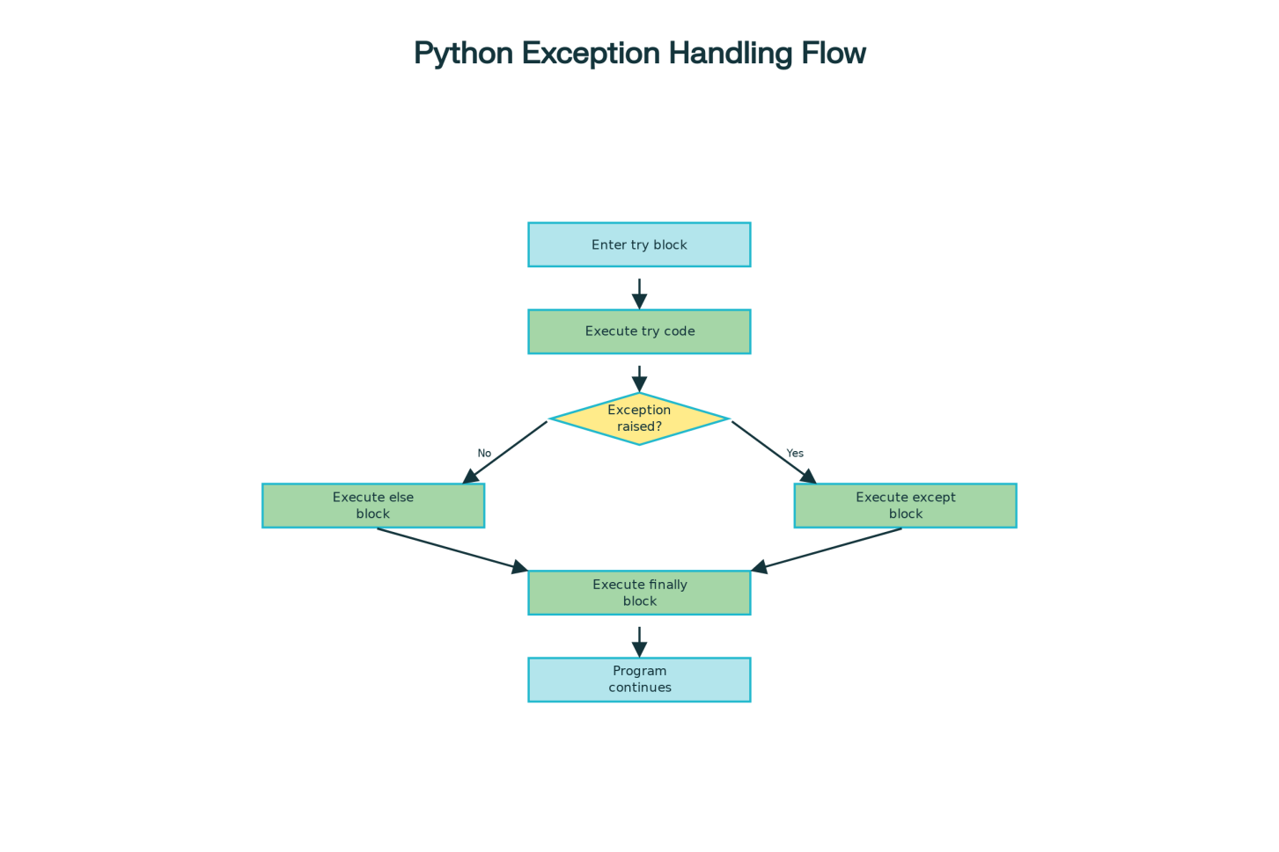
Python Exception Handling Flow Diagram
The else Block
The else block executes only if the try block completes without raising an exception. This block is useful for code that should only run when the try block succeeds.
try:
result = 10 / 2
except ZeroDivisionError:
print("Cannot divide by zero")
else:
print(f"Division result: {result}")
The else block must come after all except blocks. It's commonly used when you want to separate error handling code from success code:
def find_element(lst, index):
try:
element = lst[index]
except IndexError:
print(f"Index {index} out of range")
else:
# This runs only if lst[index] succeeds
print(f"Found element: {element}")
find_element([1, 2, 3], 1) # Prints: Found element: 2
find_element([1, 2, 3], 10) # Prints: Index 10 out of range
The finally Block
The finally block executes no matter what—whether an exception occurred or not. This block is essential for cleanup operations like closing files, releasing resources, or saving state.
def read_file_demo(filename):
file = None
try:
file = open(filename, 'r')
content = file.read()
print(f"Read {len(content)} characters")
except FileNotFoundError:
print("File not found")
finally:
# This always executes
if file:
file.close()
print("File closed")
The finally block is guaranteed to execute even if:
- An exception occurs in the try block
- An exception occurs in an except block
- A return statement is executed
- A break or continue statement is executed
This makes finally ideal for resource management:
def process_transaction(amount):
try:
if amount > 1000:
raise ValueError("Amount exceeds limit")
print(f"Processing ${amount}")
except ValueError as e:
print(f"Error: {e}")
finally:
# Always runs regardless of success/failure
print("Logging transaction...")
print("Sending notification...\n")
process_transaction(100)
process_transaction(2000)
Raising Exceptions with raise
You use the raise statement to explicitly raise exceptions when your code detects invalid conditions. This allows you to enforce constraints and validate input:
def validate_age(age):
if not isinstance(age, int):
raise TypeError("Age must be an integer")
if age < 0:
raise ValueError("Age cannot be negative")
if age < 18:
raise ValueError("Age must be at least 18")
try:
validate_age(25)
except (TypeError, ValueError) as e:
print(f"Validation error: {e}")
Re-raising Exceptions
Sometimes you want to catch an exception, perform some action (like logging), and then re-raise it for an outer handler:
def process_with_logging(data):
try:
return int(data)
except ValueError as e:
print(f"Logging: Could not convert '{data}'")
raise # Re-raise the same exception
try:
process_with_logging("abc")
except ValueError:
print("Outer handler caught the error")
The bare raise statement re-raises the currently handled exception without modifying it.
Exception Chaining with from
When raising a new exception due to catching another, use from to preserve the exception chain:
try:
try:
file = open("config.json")
except FileNotFoundError as e:
raise RuntimeError("Cannot load configuration") from e
except RuntimeError as e:
print(f"Error: {e}")
print(f"Caused by: {e.__cause__}")
The from syntax creates a chain showing the original cause of the error, making debugging easier.
Creating Custom Exception Classes
Custom exceptions allow you to create domain-specific error types that make your code more expressive. A custom exception is simply a class that inherits from Exception or one of its subclasses.
Simple Custom Exception
class ValidationError(Exception):
"""Custom exception for validation failures"""
pass
def validate_email(email):
if "@" not in email:
raise ValidationError("Email must contain '@' symbol")
print(f"Email '{email}' is valid")
try:
validate_email("invalid-email")
except ValidationError as e:
print(f"Error: {e}")
Custom Exception with Attributes
You can add custom attributes to exceptions to store additional information:
class StudentGradeError(Exception):
"""Exception for invalid student grades"""
def __init__(self, name, grade, message="Invalid grade"):
self.name = name
self.grade = grade
self.message = message
super().__init__(self.message)
def __str__(self):
return f"{self.message}: {self.name} got {self.grade}"
def record_grade(name, grade):
if not (0 <= grade <= 100):
raise StudentGradeError(name, grade, "Grade out of range")
print(f"Recorded: {name} - {grade}")
try:
record_grade("Raj", 85)
record_grade("Priya", 105)
except StudentGradeError as e:
print(f"Error: {e}")
print(f" Student: {e.name}")
print(f" Grade: {e.grade}")
Creating Exception Hierarchies
You can create hierarchies of custom exceptions to organize related errors:
class AccountError(Exception):
"""Base class for account errors"""
def __init__(self, message, error_code=None):
self.message = message
self.error_code = error_code
super().__init__(self.message)
class InsufficientFundsError(AccountError):
"""Raised when account balance is insufficient"""
pass
class InvalidAmountError(AccountError):
"""Raised when transaction amount is invalid"""
pass
class BankAccount:
def __init__(self, balance=0):
self.balance = balance
def withdraw(self, amount):
if amount <= 0:
raise InvalidAmountError("Amount must be positive", "INVALID_AMT")
if amount > self.balance:
raise InsufficientFundsError(
f"Insufficient funds (have: ${self.balance}, need: ${amount})",
"INSUFFICIENT_FUNDS"
)
self.balance -= amount
print(f"Withdrew ${amount}. New balance: ${self.balance}")
account = BankAccount(1000)
try:
account.withdraw(500)
except AccountError as e:
print(f"Error [{e.error_code}]: {e.message}")
This hierarchical approach allows catching all account-related errors with a single except AccountError: block, or catching specific error types when needed.
File Handling Exceptions
File operations are a common source of exceptions. Python provides specific exception types for file-related errors.
FileNotFoundError
The FileNotFoundError is raised when attempting to open a file that doesn't exist:
def read_file_safe(filename):
try:
with open(filename, 'r') as file:
content = file.read()
return content
except FileNotFoundError:
print(f"Error: File '{filename}' not found")
return None
content = read_file_safe("missing.txt")
Always use try-except when working with files you don't know exist.
ValueError in File Operations
ValueError commonly occurs when converting file content to another type:
def read_numbers_from_file(filename):
numbers = []
try:
with open(filename, 'r') as file:
for line_num, line in enumerate(file, 1):
try:
num = int(line.strip())
numbers.append(num)
except ValueError:
print(f"Warning: Line {line_num} '{line.strip()}' is not a valid integer")
except FileNotFoundError:
print(f"Error: File '{filename}' not found")
return numbers
This example catches ValueError for each line (invalid conversion) separately from FileNotFoundError for the file operation.
Other File Exceptions
- IOError: General I/O failure when reading or writing
- PermissionError: Insufficient permissions to access the file
- IsADirectoryError: Path is a directory, not a file
def safe_write_log(filename, message):
try:
with open(filename, 'a') as file:
file.write(f"{message}\n")
print(f"Message written to {filename}")
except PermissionError:
print(f"Error: No permission to write to {filename}")
except IOError as e:
print(f"I/O error: {e}")
Using context managers (with statement)
The with statement is the Pythonic way to handle files because it automatically closes the file even if an exception occurs:
try:
with open("data.txt", 'r') as file:
data = file.read()
# File is automatically closed here
except FileNotFoundError:
print("File not found")
Using with ensures proper resource cleanup without needing an explicit finally block.
Best Practices for Exception Handling
- Be specific: Catch specific exceptions rather than using bare except:. A bare except: catches everything including keyboard interrupts and system exits.
- Don't ignore exceptions silently: Always inform the user or log when an exception occurs.
- Clean up resources: Use finally or context managers (the with statement) to ensure resources are freed.
- Use exceptions for exceptional situations: Don't use exceptions for normal control flow.
- Create custom exceptions: When your application has domain-specific errors, create custom exception classes.
- Preserve exception context: Use from when raising new exceptions from caught ones to maintain the exception chain.
- Document exceptions: Include information about what exceptions a function might raise in its docstring.
- Test exception handling: Write tests to verify that your exception handlers work correctly.
Summary
Python's exception handling model provides a structured way to manage errors and abnormal situations. The try block contains code that might fail, except blocks handle specific exceptions, the else block executes on success, and the finally block ensures cleanup operations always run. The raise statement allows you to explicitly raise exceptions when your code detects invalid conditions. Custom exception classes enable you to create domain-specific error types that make your code more expressive and maintainable. File handling exceptions like FileNotFoundError and ValueError are common when working with files. By combining these tools—try-except-else-finally blocks, raising and catching specific exceptions, creating custom exception hierarchies, and handling file-related errors—you can write robust Python code that handles unexpected situations gracefully and provides clear feedback when problems occur.

